Create Authentication Service that Returns JWT

application.properties

spring.application.name=spring-learn-auth
server.port=8090

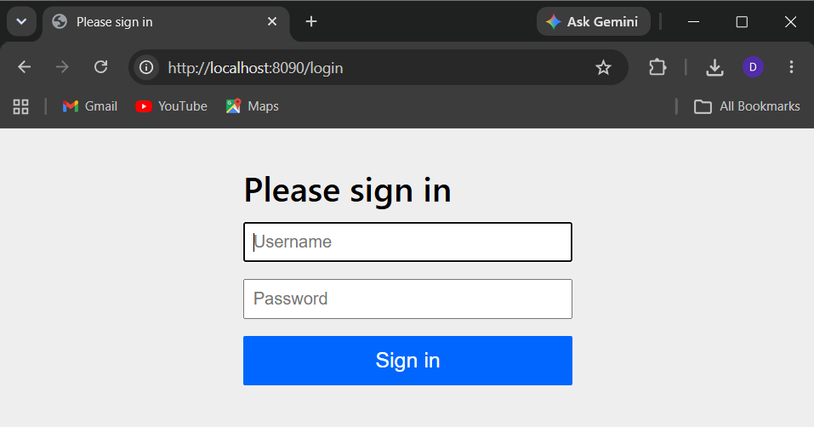

SecurityConfig.java

package com.cognizant.spring_learn_auth.config;

import org.springframework.context.annotation.Bean;
import org.springframework.context.annotation.Configuration;
import org.springframework.security.config.Customizer;
import org.springframework.security.config.annotation.web.builders.HttpSecurity;
import org.springframework.security.web.SecurityFilterChain;

@Configuration
public class SecurityConfig {

@Bean
SecurityFilterChain securityFilterChain(HttpSecurity http) throws Exception {

http
.csrf(csrf -> csrf.disable())
.authorizeHttpRequests(auth -> auth
.requestMatchers("/authenticate").authenticated()
.anyRequest().permitAll()
)
.httpBasic(Customizer.withDefaults())
.formLogin(form -> form.disable());

return http.build();
}
}

AuthenticationController.java

package com.cognizant.spring_learn_auth.controller;

import java.util.Base64;

import org.springframework.web.bind.annotation.GetMapping;
import org.springframework.web.bind.annotation.RequestHeader;
import org.springframework.web.bind.annotation.RestController;

@RestController
public class AuthenticationController {

@GetMapping("/authenticate")
public String authenticate(
@RequestHeader("Authorization") String authorizationHeader) {

String base64Credentials =
authorizationHeader.substring("Basic ".length());

byte[] decodedBytes =
Base64.getDecoder().decode(base64Credentials);

String credentials = new String(decodedBytes);

return "Received Credentials : " + credentials;
}
}

